­­

APTECH

**SFC CENTER**

## E-PROJECT

### 1st-SEMESTER (CPISM)

**RYAN SPORTS CLUB**

**PARTICIPANTS**

|  |  |
| --- | --- |
| Fahad Faisal: | 1356168 |
| Muhammad Ali Hamza:  Huzaifa Hashmi:  Zubaidah Mudassir: | 1351551  1353232  1352560 |



***`***

**ACKNOWLEDGEMENT**

***First of all we would like to thank Almighty Allah. Then we would like to thank our faculty Sir Sohail for their guidance throughout the project. Our website wouldn't be the same without them as it is now. We also want to express our sincere gratitude towards E-project team from Aptech Head Office for their co-operation. At the end, we would like to express my gratitude to my friends and respondents for the support and willingness directly or indirectly to spend some time to fill in the questionnaires.***

# Certificate Of

**Completion**

**KARACHI, PAKISTAN**

**RYAN SPORTS CLUB**

***We here by affirm to the best of our knowledge and belief, based on the observation, inspection, testing of our website and upon reports submitted by others, that this website is completely operable. Our website is completed according to instructions provided by your department.***

**INTRODUCTION**

The thirst for learning, upgrading technical skills and applying the concepts in real life environment at a fast pace is what the industry demands from IT professionals today. However busy work schedules, far-flung locations, unavailability of convenient time-slots pose as major barriers when it comes to applying the concepts into realism. And hence the need to look out for alternative means of implementation in the form of laddered approach.

The above truly pose as constraints especially for our students too! With their busy schedules, it is indeed difficult for our students to keep up with the genuine and constant need for integrated application which can be seen live especially so in the field of IT education where technology can change on the spur of a moment. *Well, technology does come to our rescue at such times!!*

Keeping the above in mind and in tune with our constant endeavour to use Technology in our training model, we at Aptech have thought of revolutionizing the way our students learn and implement the concepts using tools themselves by providing a live and synchronous eProject learning environment!

**So what is this eProject?**

eProject is a step-by-step learning environment that closely simulates the classroom and Lab based learning environment into actual implementation. It is a project implementation at your fingertips!! An electronic, live juncture on the machine that allows you to

* Practice step by step i.e. laddered approach.
* Build a larger more robust application.
* Usage of certain utilities in applications designed by user.
* Single program to unified code leading to a complete application.
* Learn implementation of concepts in a phased manner.
* Enhance skills and add value.
* Work on real life projects.
* Give a real life scenario and help to create applications more complicated and useful.
* Mentoring through email support.

The students at the centre are expected to complete this eProject and send complete project along with the documentation to eProjects Team

Looking forward to a positive response from your end!!

## Objectives of the project

The Objective of this program is to give a sample project to work on real life projects. These applications help you build a larger more robust application.

The objective is not to teach you JavaScript/Dreamweaver but to provide you with a real life scenario and help you create basic applications using the tools.

You can revise the chapters before you start with the project.

This project is meant for students who have completed the module of ***Dreamweaver***. These programs should be done in the Lab sessions with assistance of the faculty if required.

It is very essential that a student has a clear understanding of the subject. Students should go through the project and solve the assignments as per requirements given.

Kindly get back to eProjects Team in case of any doubts regarding the application or its objectives.

**Problem Statement**

RYAN Sports Club, an effort has been made to provide a world class facilities and infrastructure for the promotion of sports and health. During the past time, RYAN sports club has emerged as one of the best facilities in the country in the area of sports and health and also it is making strides to acquire a formidable presence in the international. The club provides the facilities like “Indoor Sports”, Outdoor Sports” and “Recreation”. All this information is required to be presented in organized form for which a website is required to be created.

**Requirement Specification:**

The Web site is to be created based on the following requirements.

1. The Home Page with some description about the club with proper template designed. (Also navigational link must be included.)
2. The link facilities like “Indoor Sports”, Outdoor Sports” and “Recreation” .
3. Membership link must be added in the website. ( a dummy form is supposed to be fill and submitted).
4. List of the activities arranged yearly.
5. Suggestion and complaints
6. Feedback
7. Contact Us
8. Information must be added for each type of sports played (like rules, images, information, some famous players and Timings so on)
9. List of the top of sports person can be added in the website.
10. Navigation facilities must be made précised in the application.
11. Picture gallery must be added in the application.

## Hardware/ Software

**Requirements**

##### Hardware

* + *A minimum computer system that will help you access all the tools in the courses is a Pentium 166 or better*
  + *64 Megabytes of RAM or better*

##### Software

* + *Notepad/HTML editor*
  + *Dreamweaver*
  + *IE 5.0/ Netscape 6.0*

## HOME



**CODING:**

­­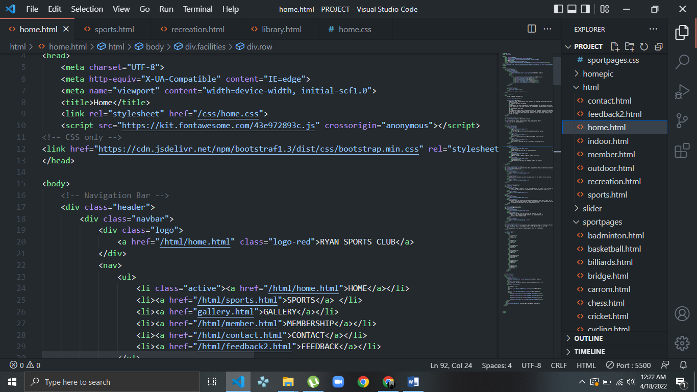

**FACILITIES**

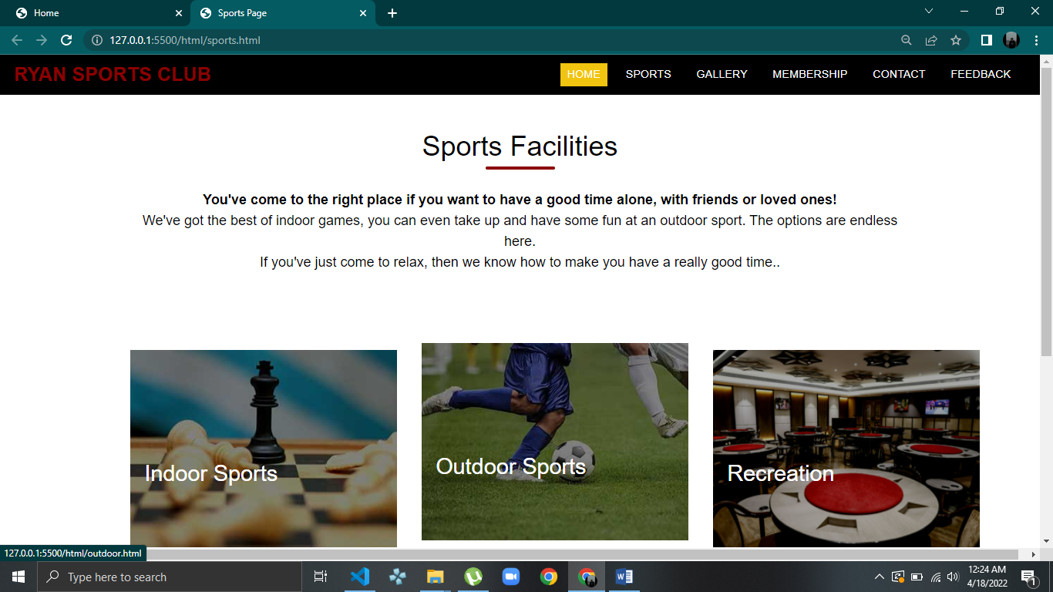

**CODING:**

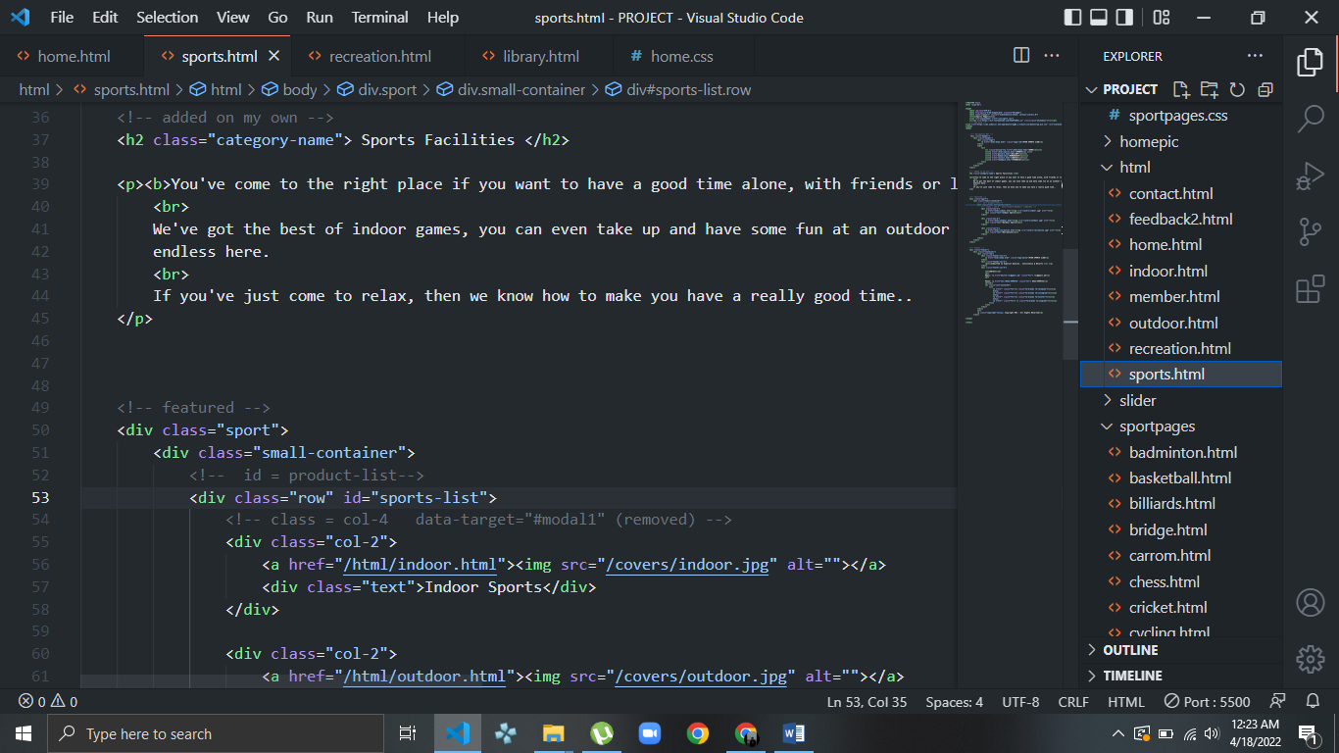

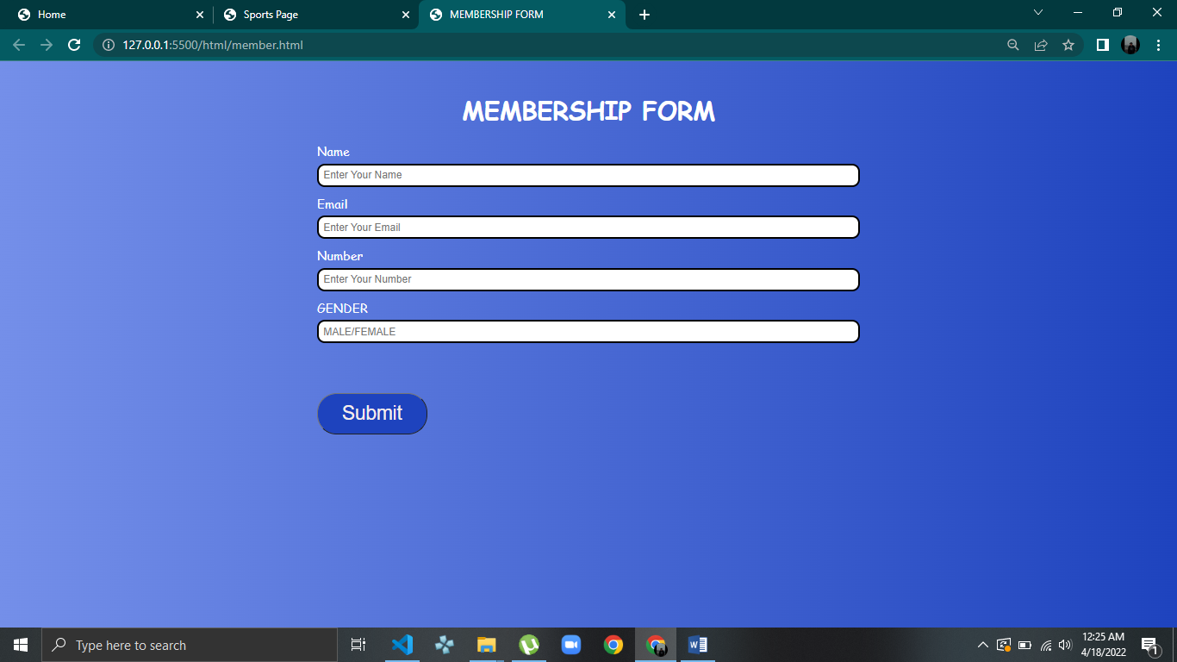**MEMBESHIP**

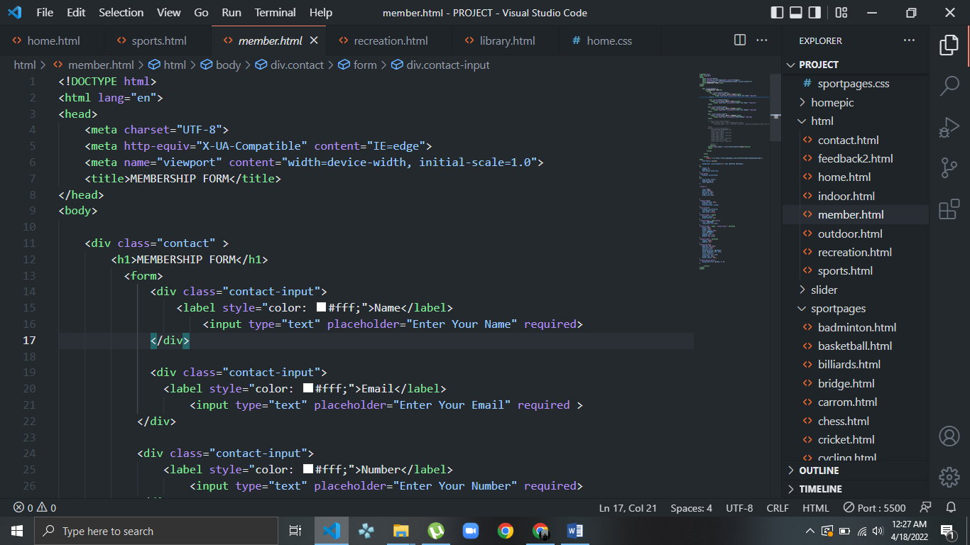**CODING:**

**FEEDBACK**

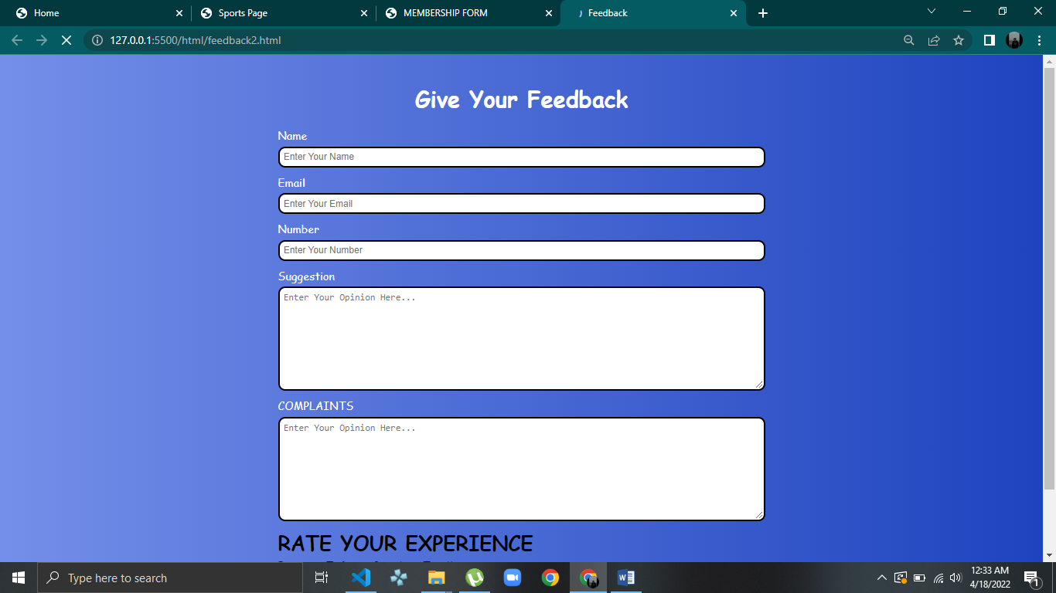

**CODING:**

